**DAILY ONLINE ACTIVITIES SUMMARY**

|  |  |  |  |  |  |  |  |
| --- | --- | --- | --- | --- | --- | --- | --- |
| **Date:** | **19-05-2020** | | | | **Name:** | **Gudugunti Anirudh** | |
| **Sem & Sec** | **IV - A** | | | | **USN:** | **4al18cs023** | |
| **Online Test Summary** | | | | | | | |
| **Subject** | | **DAA** | | | | | |
| **Max. Marks** | | **30** | | **Score** | | **9** | |
| **Certification Course Summary** | | | | | | | |
| **Course** | **Python in ML** | | | | | | |
| **Certificate Provider** | | | **Great learning academy** | **Duration** | | | **2 hrs** |
| **Coding Challenges** | | | | | | | |
| **Problem Statement:**1. To check whether one string is a sub sequence of another string  2. To find the short palindrome of a string | | | | | | | |
| **Status: Uploaded** | | | | | | | |
| **Uploaded the report in Github** | | | | **Yes** | | | |
| **If yes Repository name** | | | | **https://github.com/Anirudh23-23/Daily-progress** | | | |
| **Uploaded the report in slack** | | | | **Yes** | | | |

Online Test Details: The online test was from module 1 which was about Introduction to the subject and asymptotic notations. There were 25 questions and the duration were 30 minutes. The questions were optimal and were easy. The score that I received was 9/30.

**Snapshot**: not taken

Certification Course Details:

: Anaconda installation

:Jupyter installation

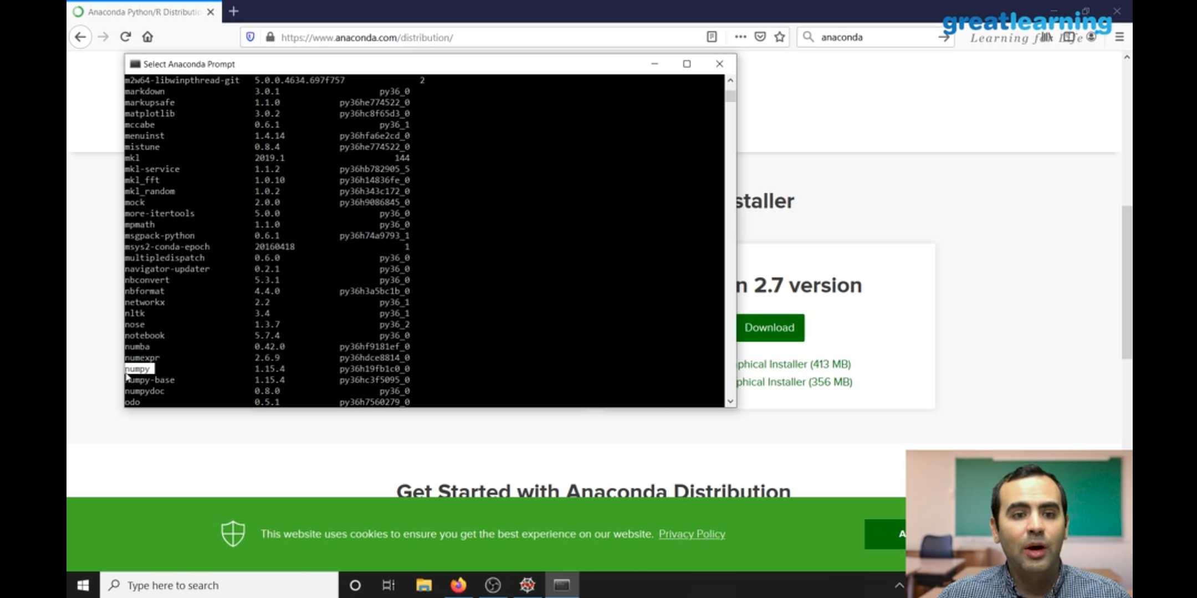

Coding Cha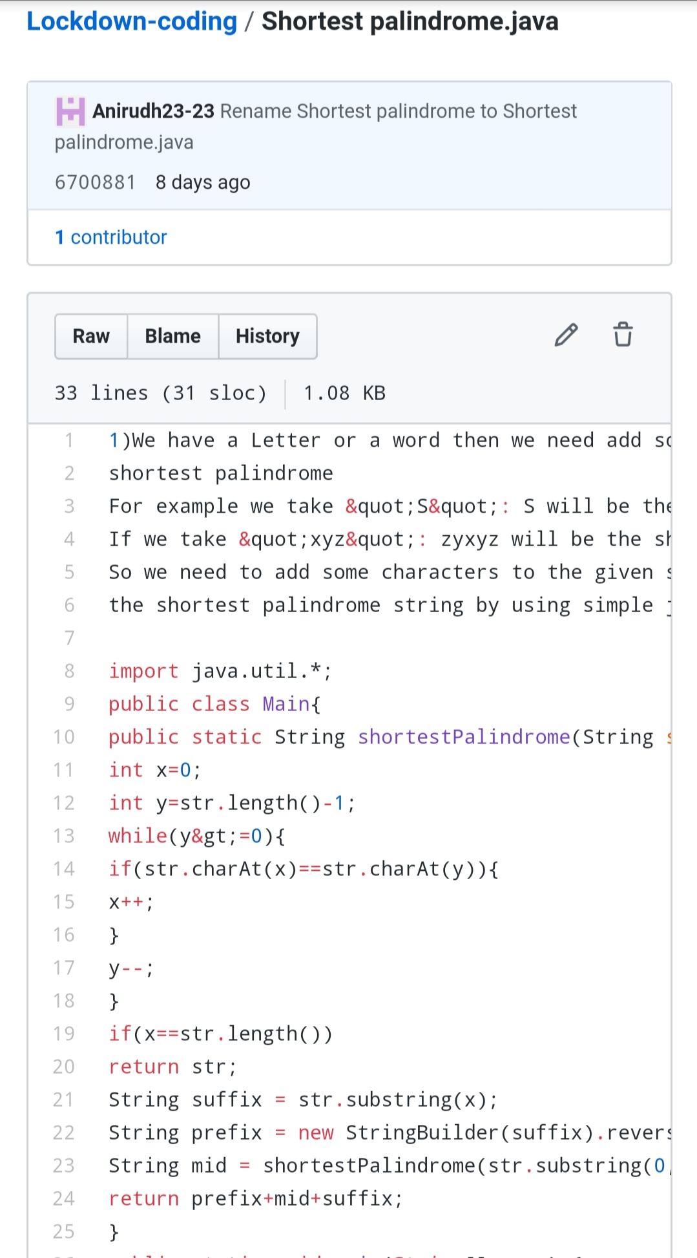llenges Details:

shortest palindrome string. If we take “xyz”, “zyxyz” will be the shortest palindrome string. So we need to add some characters to the given string or character and find out what will be the shortest palindrome string.

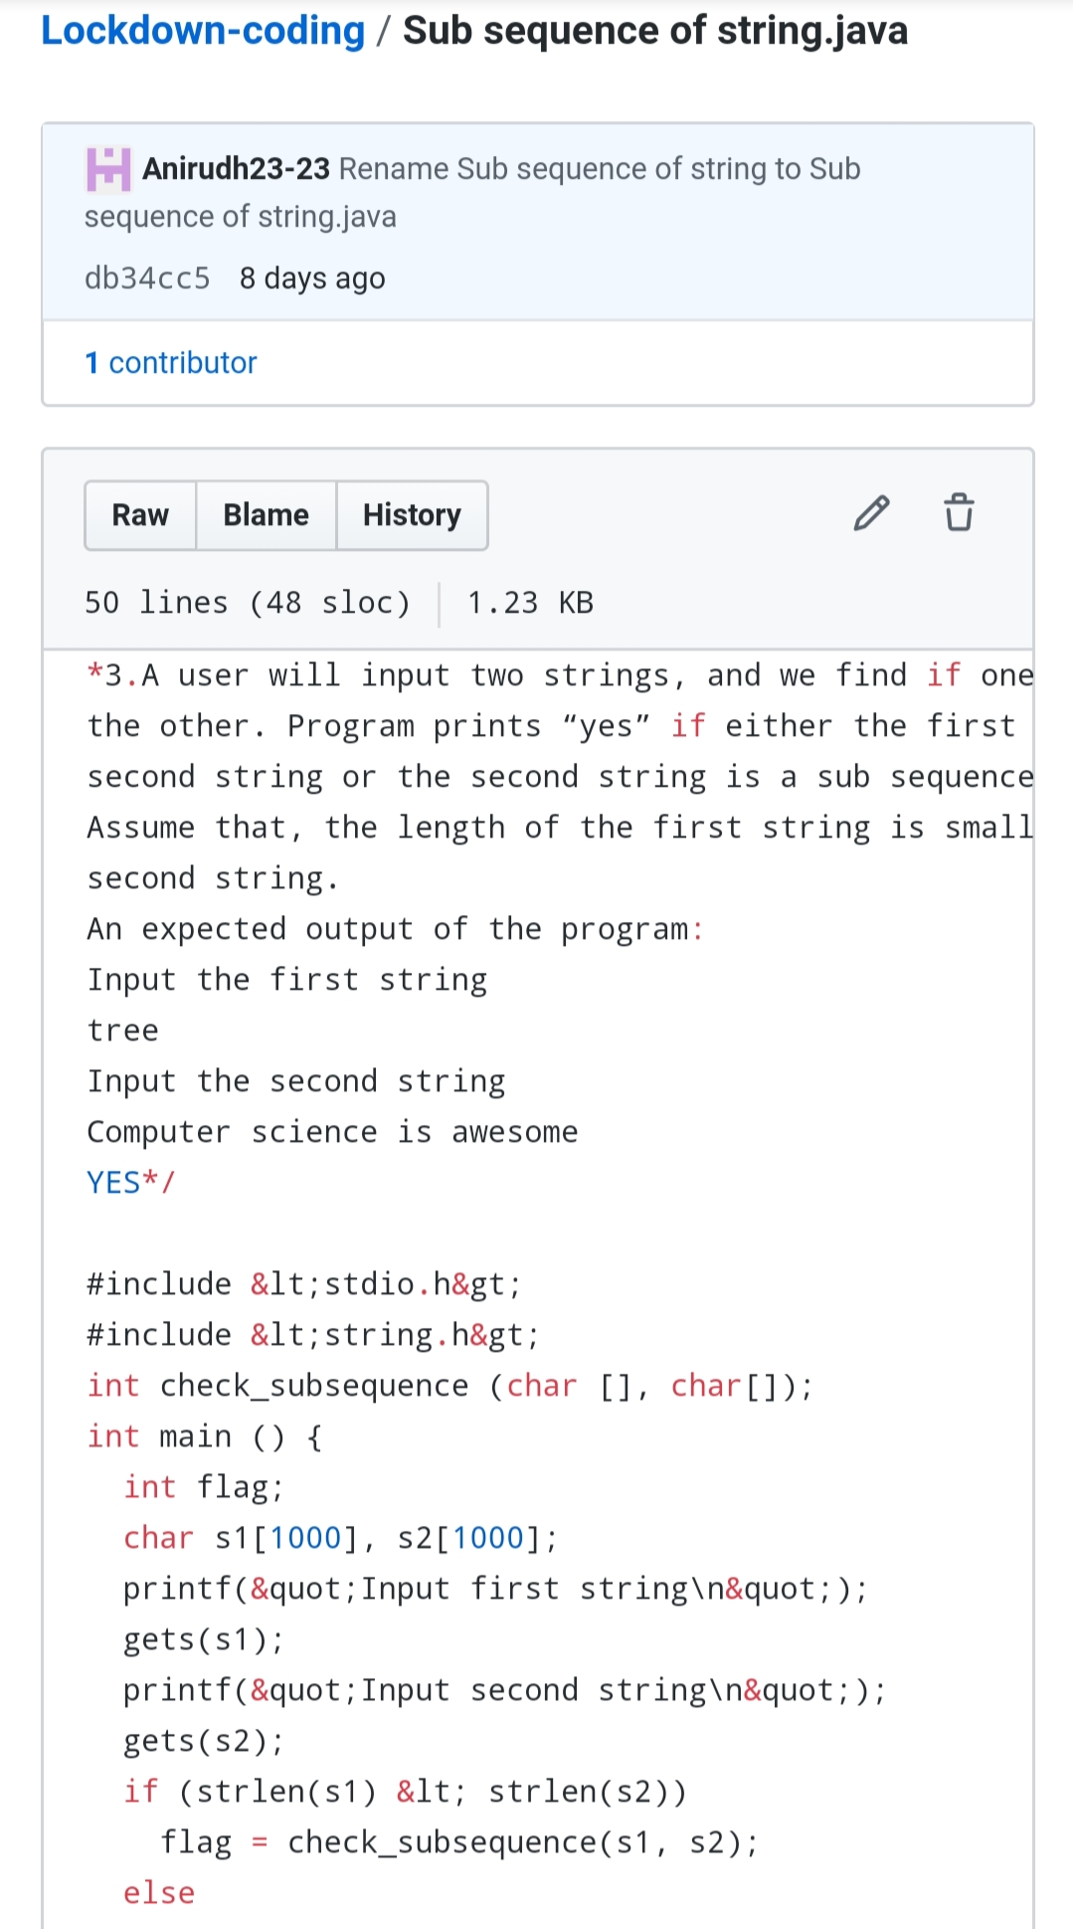Sub sequence of a string:(using C language) A user will input two strings, and we find if one of the strings is a sub sequence of the other. Program prints “yes” if either the first string is a sub sequence of the second string or the second string is a sub sequence of the first string. Assume that, the length of the first string is smaller than or equal to the length of the second string.